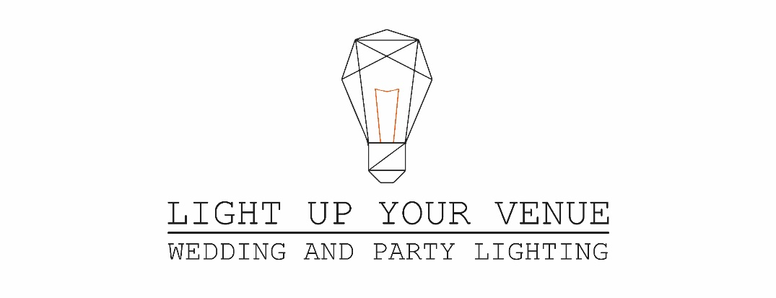
Booking Form
Customer Details
Name……………………………………………………………………….. Address………………………………………………………………..
Telephone (Day)……………………………………………………….. …………………………………………………………………………….
Telephone (Mobile)………………………………………………….. Email…………………………………………………………………….

Event Details
Event Date…………………………………………………………….... Start Time……………………End Time………………………..
Venue Name…………………………………………………………….. Venue Address……………………………………………………..
Room Name (if applicable) ……………………………………….. ……………………………………………………………………………..
Hire Items………………………………………………………………………………………………………………………………………………………

We always confirm your booking in writing, and each booking is subject to the ‘Terms and Conditions’ which will be sent by email separately.
Deposits
We take a non-refundable deposit upon booking The deposit amount will be advised depending on items hired. We can also set up a monthly instalment plan if you would like to spread the cost between now and your event.

The balance is due 4 weeks before the event. Although you are more than welcome to pay the full amount upon booking or anytime leading up to the event but the full amount must be paid 4 weeks before. You will receive an automated payment reminder just before the balance due date.

We can email you an invoice or if you prefer or we can send you a printed copy.

We accept Cash, PayPal and BACS. Sort Code 08-71-99 Account Number 03622238. Unfortunately, we do not accept cheques. We apologise for any inconvenience this may cause.

Contact
If you need to contact us for any reason you can do so by email info@lightupyourvenue.co.uk or call
07593 893 201. Please return this form to 37 Balmoral Road, Dumfries DG1 3BE OR email us all the details.

LUYV Team.

